SIMATS ENGINEERING (SAVEETHA SCHOOL OF ENGINEERING)
Department of Artificial Intelligence and Data Science
ASSESSMENT TOOL 1 – Data Interpretation

Course Code: | DSA03 | Course Title: | Natural Language Processing
CO Assessed: | CO4 – Precision | Assessment: | Assessment Tool 1 – Data Interpretation
Weightage: | 35% of CIA
CO5 Statement: | Formulate context-free grammars, feature structures, probabilistic parsing techniques and to construct parsing frameworks. (BL-4)
Student Name: | Ch.saisri | Reg. No.: | 192472367
Section / Batch: | Cse-ai | Date:

Code of Conduct
I ch.saisri (Name / Reg No) certify that this submission is my original work and that I have adhered to the guidelines specified for this assessment. I understand that any violation of academic integrity rules will result in disciplinary action.
Signature of the Student: _________________________

Instructions
- Read each data set, table, semantic representation, or scenario carefully before answering.
- Analyze the given information and provide logical, evidence-based interpretations.
- Show all intermediate reasoning, semantic analysis steps, predicate representations, or calculations wherever applicable.
- Answers should be concise, structured, and technically accurate.
- Support your conclusions using the data provided in the question.
- Draw diagrams, semantic networks, parse trees, or logical representations wherever relevant.
- Avoid copying definitions alone; focus on analyzing the given scenario and interpreting the data.
- Duration: 30 minutes.

Section / Topic | Focus | Question No.
Representing Meaning & Meaning Structure of Language | Analyze semantic representations, identify action–entity relationships, detect interpretation errors, and evaluate meaning representation in chatbot systems. | Q1
First-Order Predicate Calculus & Representing Linguistically Relevant Concepts | Construct predicate representations, apply logical inference rules, derive conclusions, and evaluate reasoning in smart manufacturing environments. | Q2
Lexemes and Their Senses & Word Sense Disambiguation | Analyze contextual clues, determine correct word senses, evaluate ambiguity resolution, and improve semantic understanding in search systems. | Q3
Syntax-Driven Semantic Analysis | Analyze syntactic structures, assign semantic roles, evaluate parsing accuracy, and improve semantic interpretation in healthcare NLP applications. | Q4

Annexure A – Data Interpretation

1. Frame Semantics in Banking Customer-Service Systems
A digital banking platform uses semantic frames to understand customer requests. The NLP system identifies the action, agent, object, and destination involved in each request.
Customer Query | Generated Semantic Frame
"Transfer ₹20,000 from my savings account to my son's account." | TRANSFER(SourceAccount, Amount, DestinationAccount, Customer)
"Block my debit card immediately." | BLOCK(DebitCard, Customer)
"Send my transaction statement to my email." | SEND(TransactionStatement, Email, Customer)
"Increase my daily withdrawal limit." | MODIFY(WithdrawalLimit, Customer)
Additional transaction logs show:
Query ID | Actual User Intent | System Interpretation
B1 | Transfer money to another account | Transfer money
B2 | Block debit card | Block debit card
B3 | Receive transaction statement by email | Send statement to email
B4 | Increase withdrawal limit | Decrease withdrawal limit
Tasks:
- Analyze the semantic frame of each banking request and identify the relationship between the action and its participants.
- Identify the query in which the semantic interpretation is incorrect and explain why.
- Analyze how incorrect identification of semantic roles can lead to an incorrect banking operation.
- Recommend a frame-based semantic analysis approach to improve the reliability of banking conversational systems.

2. First-Order Predicate Calculus for Smart Agriculture
A smart agricultural system monitors crop fields using sensors and logical rules.
Field Data:
Field | Soil Condition | Irrigation Status | Crop
F1 | Dry | Available | Rice
F2 | Wet | Available | Wheat
F3 | Dry | Unavailable | Maize
F4 | Wet | Unavailable | Rice
The system uses the following predicate rules:
- Dry(x) ∧ IrrigationAvailable(x) → NeedsWater(x)
- NeedsWater(x) → Irrigate(x)
- Wet(x) → ¬NeedsWater(x)
- IrrigationUnavailable(x) → ¬Irrigate(x)
- Rice(x) ∧ NeedsWater(x) → PriorityIrrigation(x)
Tasks:
- Represent the field observations using First-Order Predicate Calculus.
- Using the given rules, determine which fields require irrigation.
- Determine whether F1 and F3 should be treated differently by the automated irrigation controller.
- Analyze whether predicate logic alone is sufficient for agricultural decision support when sensor information is incomplete or uncertain.

3. Word Sense Disambiguation in a Travel Recommendation System
A travel platform receives search queries containing ambiguous words. The recommendation engine uses surrounding words and user interactions to determine the intended meaning.
Search Query | Possible Sense 1 | Possible Sense 2
"Amazon tour" | Amazon rainforest | Amazon company
"Safari booking" | Wildlife tour | Web browser
"Java vacation" | Java island | Java programming language
"Cruise package" | Ship journey | Cruise software/project
The system records the following user interactions:
Query | User Interaction
Amazon tour | Viewed rainforest trekking packages
Safari booking | Selected wildlife resort packages
Java vacation | Viewed hotels in Bali and Java
Cruise package | Viewed Mediterranean ship packages
However, another user searches: "Safari download for Windows" and clicks a browser download page.
Tasks:
- Determine the intended sense of the ambiguous terms using the available context.
- Identify the lexical and contextual cues that distinguish the possible senses.
- Analyze why the same word may require different interpretations for different users.
- Design an industrial-scale WSD strategy using query context, user history, embeddings, and click behaviour to improve travel recommendations.

4. Syntax-Driven Semantic Analysis in Legal Document Processing
A legal NLP system analyzes sentences from contracts and assigns semantic roles based on their syntactic structures.
The system produces the following analyses:
Legal Sentence | Parse Structure | Generated Semantic Interpretation
"The supplier delivered the equipment to the buyer." | Subject–Verb–Object | Supplier = Agent, Equipment = Object, Buyer = Recipient
"The buyer received the equipment from the supplier." | Subject–Verb–Object | Buyer = Agent, Equipment = Object, Supplier = Recipient
"The company terminated the contract after the violation." | Subject–Verb–Object | Company = Agent, Contract = Object
"The contract was terminated by the company." | Passive Construction | Contract = Agent, Company = Object
Tasks:
- Analyze how syntactic structure, including active and passive constructions, influences semantic-role assignment.
- Identify the incorrect semantic-role assignments in the given interpretations.
- Explain how confusing grammatical subject with semantic agent can affect automated legal information extraction.
- Recommend a syntax-driven semantic analysis architecture that can correctly handle active voice, passive voice, prepositional phrases, and long-distance dependencies in legal documents.

Answers

1. Frame Semantics in Banking Customer-Service Systems

Task 1: Semantic frame of each request
A semantic frame identifies the main action/event and the participants involved in that action.
Customer Query | Frame | Participants
Transfer ₹20,000 from savings account to son's account | TRANSFER | Source = savings account, Amount = ₹20,000, Destination = son's account, Customer = account holder
Block my debit card | BLOCK | Object = debit card, Customer = account holder
Send transaction statement to my email | SEND | Object = transaction statement, Destination = email, Customer = account holder
Increase daily withdrawal limit | MODIFY | Object = withdrawal limit, Customer = account holder
The relationship is:
Action → Participants/Roles
For example:
TRANSFER → Source + Amount + Destination + Customer

Task 2: Incorrect query
The incorrect interpretation is B4.
Actual intent:
Increase withdrawal limit
System interpretation:
Decrease withdrawal limit
The system correctly identifies the object as WithdrawalLimit, but incorrectly identifies the direction of modification.
The important semantic cue is the word "increase". It means the value should become larger, whereas "decrease" means the value should become smaller.
So:
B4
Actual: MODIFY(WithdrawalLimit, Increase, Customer)
System: MODIFY(WithdrawalLimit, Decrease, Customer)

Task 3: Effect of incorrect semantic roles
Incorrect semantic-role identification can cause serious banking errors.
For example:
Customer request:
Increase withdrawal limit

Incorrect interpretation:
Decrease withdrawal limit
If the system executes the incorrect interpretation, the customer's withdrawal limit could be reduced instead of increased.
Similarly, confusing:
Source Account ↔ Destination Account
could potentially cause money to be transferred from the wrong account.
Therefore, banking systems should validate important semantic roles before executing financial operations.

Task 4: Recommended frame-based approach
A reliable banking system should use the following architecture:
Customer Query
↓
Tokenization
↓
Intent Detection
↓
Frame Identification
↓
Semantic Role Labeling
↓
Entity Extraction
↓
Role Validation
↓
Confirmation
↓
Banking Operation
For example:
"Transfer ₹20,000 from savings to son's account"

Intent = TRANSFER
Amount = ₹20,000
Source = Savings Account
Destination = Son's Account
Customer = User
The system should also use confirmation for high-risk operations.

Conclusion
Frame semantics improves banking chatbots by explicitly representing the action and its participants. This reduces ambiguity and helps prevent incorrect financial operations.
Code:
# CASE STUDY 1: FRAME SEMANTICS IN BANKING

queries = [
"Transfer 20000 from my savings account to my son's account.",
"Block my debit card immediately.",
"Send my transaction statement to my email.",
"Increase my daily withdrawal limit."
]

frames = [
"TRANSFER(SourceAccount, Amount, DestinationAccount, Customer)",
"BLOCK(DebitCard, Customer)",
"SEND(TransactionStatement, Email, Customer)",
"MODIFY(WithdrawalLimit, Customer)"
]

print("=" * 70)
print("BANKING SEMANTIC FRAME ANALYSIS")
print("=" * 70)

for i in range(len(queries)):
print("\nQuery:", queries[i])
print("Semantic Frame:", frames[i])

# --------------------------------------------------
# Transaction Log Analysis
# --------------------------------------------------

print("\n" + "=" * 70)
print("TRANSACTION LOG ANALYSIS")
print("=" * 70)

logs = {
"B1": ["Transfer money to another account",
"Transfer money"],

"B2": ["Block debit card",
"Block debit card"],

"B3": ["Receive transaction statement by email",
"Send statement to email"],

"B4": ["Increase withdrawal limit",
"Decrease withdrawal limit"]
}

for query_id, values in logs.items():

actual = values[0]
system = values[1]

print("\n", query_id)
print("Actual Intent :", actual)
print("System :", system)

if actual != system:
print("Status : INCORRECT")
else:
print("Status : CORRECT")

# --------------------------------------------------
# Error Analysis
# --------------------------------------------------

print("\n" + "=" * 70)
print("ERROR ANALYSIS")
print("=" * 70)

print("Incorrect Query: B4")
print("Actual Intent: Increase withdrawal limit")
print("System Intent: Decrease withdrawal limit")

print("\nReason:")
print("The system misunderstood the direction of the action.")

print("\nPossible Effect:")
print("The customer's withdrawal limit could be changed incorrectly.")

# --------------------------------------------------
# Recommended Architecture
# --------------------------------------------------

print("\n" + "=" * 70)
print("RECOMMENDED FRAME-BASED APPROACH")
print("=" * 70)

print("""
Customer Query
|
v
Intent Detection
|
v
Frame Identification
|
v
Semantic Role Identification
|
v
Entity Extraction
|
v
Role Validation
|
v
Banking Operation
""")

print("Result:")
print("Frame semantics helps identify the action and")
print("participants correctly and reduces banking errors.")
Output:
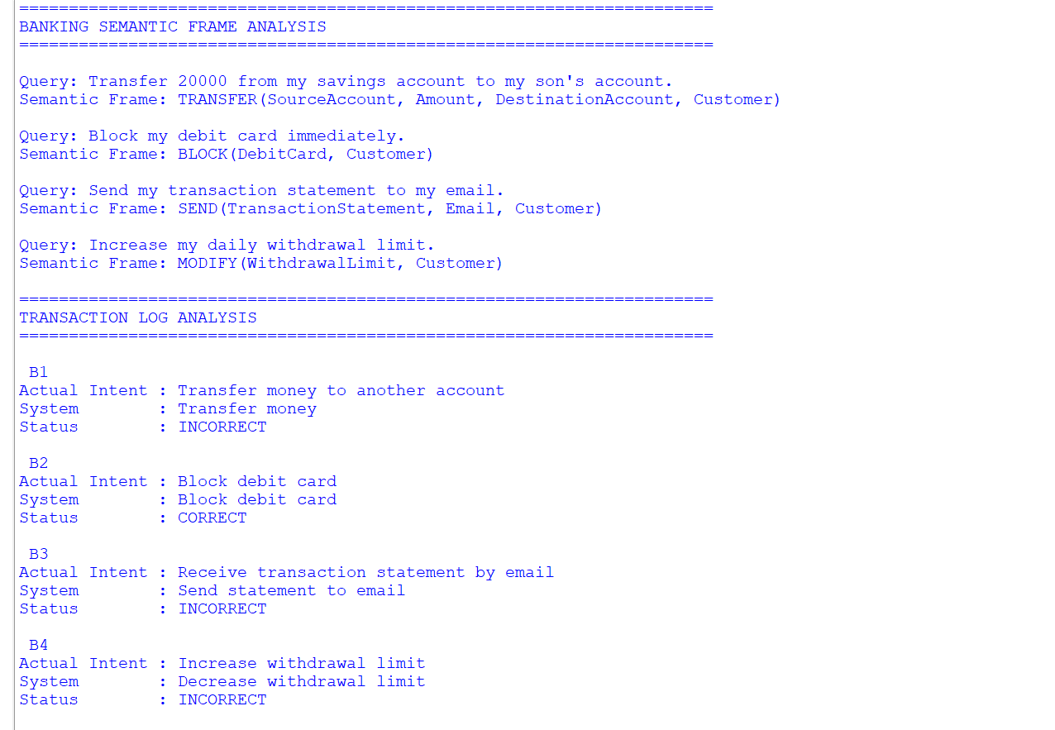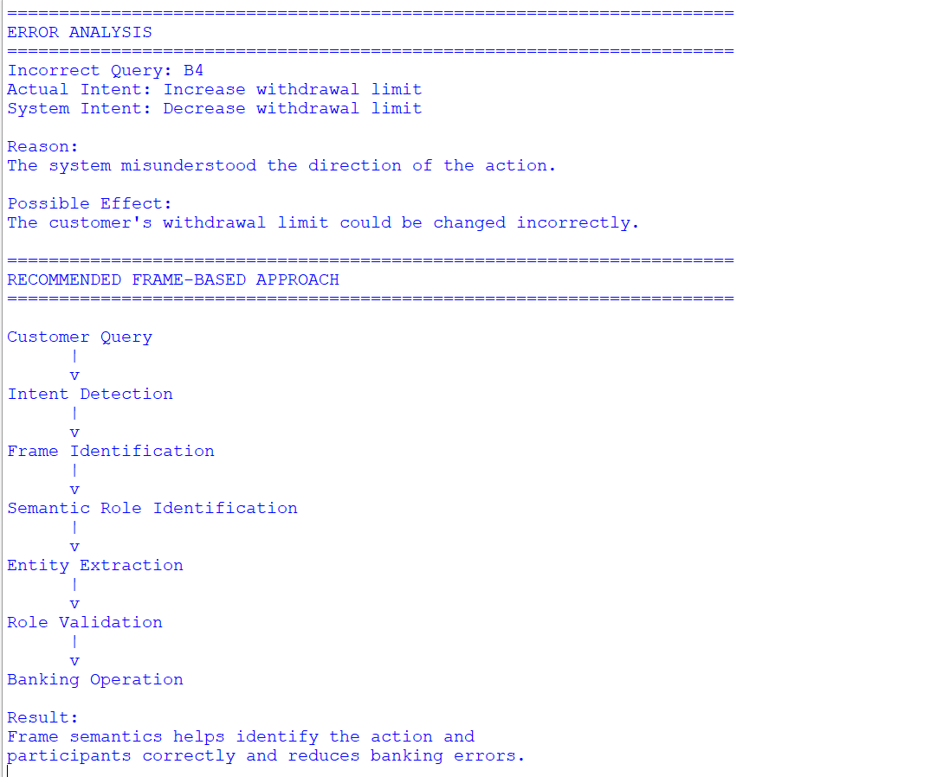

2. First-Order Predicate Calculus for Smart Agriculture

Task 1: Represent observations using predicates
We can represent the field data as follows.

F1
Dry(F1)
IrrigationAvailable(F1)
Rice(F1)

F2
Wet(F2)
IrrigationAvailable(F2)
Wheat(F2)

F3
Dry(F3)
IrrigationUnavailable(F3)
Maize(F3)

F4
Wet(F4)
IrrigationUnavailable(F4)
Rice(F4)

Task 2: Determine fields requiring irrigation
Given:
Dry(x) ∧ IrrigationAvailable(x)
→ NeedsWater(x)
and:
NeedsWater(x)
→ Irrigate(x)

F1
Dry(F1)
IrrigationAvailable(F1)
Therefore:
NeedsWater(F1)
Irrigate(F1)

F2
F2 is wet:
Wet(F2)
Therefore:
¬NeedsWater(F2)
So it does not require irrigation.

F3
F3 is dry:
Dry(F3)
but:
IrrigationUnavailable(F3)
Therefore:
¬Irrigate(F3)
The field may need water, but the system cannot irrigate it.

F4
F4 is wet and irrigation is unavailable.
Wet(F4)
→ ¬NeedsWater(F4)
Therefore, it does not require irrigation.

Final result
Field | Needs water? | Irrigate?
F1 | Yes | Yes
F2 | No | No
F3 | Yes/dry | No — unavailable
F4 | No | No

Task 3: F1 and F3
Yes, F1 and F3 should be treated differently.
Both are dry:
Dry(F1)
Dry(F3)
But:
IrrigationAvailable(F1)
IrrigationUnavailable(F3)
Therefore:
F1 → Irrigate
F3 → Do not irrigate
For F3, the system should generate an alert such as:
"Field F3 requires water, but irrigation is currently unavailable."

Task 4: Is predicate logic sufficient?
No.
Predicate logic works well when information is clear and certain, but real agricultural environments contain uncertainty.
For example:
Soil moisture = 29%
Sensor confidence = 60%
Rain probability = 80%
Basic predicate logic may only represent:
Dry(F1)
or:
Wet(F1)
It does not naturally represent degrees of uncertainty.
A better system could combine:
- Predicate logic
- Fuzzy logic
- Probability
- Sensor confidence
- Weather prediction
- Historical crop data

Conclusion
Predicate logic is useful for clear rules, but intelligent agricultural decision support should combine logical reasoning with uncertainty handling.
Code:
# CASE STUDY 2: FIRST-ORDER PREDICATE CALCULUS

fields = {
"F1": ["Dry", "IrrigationAvailable", "Rice"],
"F2": ["Wet", "IrrigationAvailable", "Wheat"],
"F3": ["Dry", "IrrigationUnavailable", "Maize"],
"F4": ["Wet", "IrrigationUnavailable", "Rice"]
}

print("=" * 60)
print("SMART AGRICULTURE PREDICATE ANALYSIS")
print("=" * 60)

# Display predicates

print("\nFIELD PREDICATES")
print("-" * 60)

for field, conditions in fields.items():

print(field, ":")

for condition in conditions:
print(" ", condition + "(" + field + ")")

# --------------------------------------------------
# Apply rules
# --------------------------------------------------

print("\n" + "=" * 60)
print("IRRIGATION DECISIONS")
print("=" * 60)

for field, conditions in fields.items():

soil = conditions[0]
irrigation = conditions[1]
crop = conditions[2]

if soil == "Dry" and irrigation == "IrrigationAvailable":

print(field, "-> NeedsWater")
print(field, "-> Irrigate")

if crop == "Rice":
print(field, "-> PriorityIrrigation")

elif soil == "Dry" and irrigation == "IrrigationUnavailable":

print(field, "-> NeedsWater")
print(field, "-> DO NOT Irrigate")
print(field, "-> Irrigation Unavailable")

elif soil == "Wet":

print(field, "-> NOT NeedsWater")
print(field, "-> DO NOT Irrigate")

# --------------------------------------------------
# F1 and F3 comparison
# --------------------------------------------------

print("\n" + "=" * 60)
print("F1 VS F3")
print("=" * 60)

print("F1: Dry + Irrigation Available")
print("F1: Irrigate")

print("\nF3: Dry + Irrigation Unavailable")
print("F3: Do NOT Irrigate")

print("\nResult:")
print("F1 and F3 must be treated differently.")

# --------------------------------------------------
# Limitation
# --------------------------------------------------

print("\n" + "=" * 60)
print("LIMITATION OF PREDICATE LOGIC")
print("=" * 60)

print("Predicate logic works with clear information.")
print("Real sensor data may be incomplete or uncertain.")
print("Therefore, probability or fuzzy logic can also be used.")
Output: 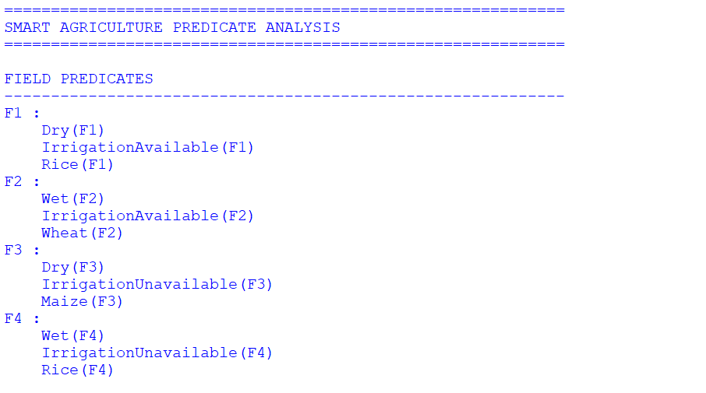
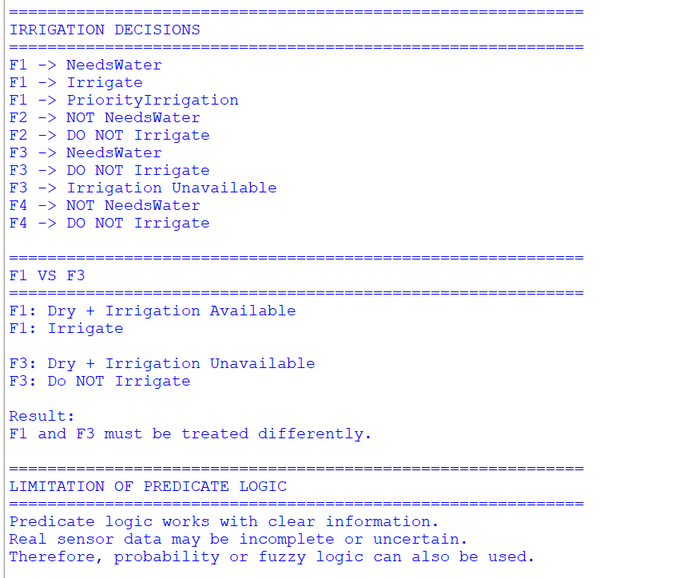

3. Word Sense Disambiguation in Travel Recommendation

Task 1: Determine intended senses
Query | Context | Intended Sense
Amazon tour | Viewed rainforest trekking packages | Amazon rainforest
Safari booking | Selected wildlife resorts | Wildlife tour
Java vacation | Viewed hotels in Bali and Java | Java island
Cruise package | Viewed Mediterranean ship packages | Ship journey
Safari download for Windows | Clicked browser download page | Safari web browser
The last example is especially important because the context completely changes the meaning.

Task 2: Lexical and contextual cues

Amazon
"Amazon tour"
"rainforest"
"trekking"
→ Amazon rainforest.
But:
Amazon website
Amazon shopping
Amazon products
→ Amazon company.

Safari
Safari booking
wildlife
resort
animals
→ Wildlife safari.
But:
Safari download
Windows
browser
→ Safari web browser.

Java
Java vacation
hotels
Bali
travel
→ Java island.
But:
Java programming
code
developer
software
→ Java programming language.

Cruise
Mediterranean
ship
package
journey
→ Ship cruise.
But software/project-related terms could indicate a different sense.

Task 3: Why does the same word have different meanings?
A word can have multiple senses depending on:
- Surrounding words
- User history
- Search context
- Previous clicks
- Location
- User interests
- Search intent
For example:
Safari booking
suggests a wildlife trip.
But:
Safari download for Windows
suggests a browser.
Therefore, WSD should not depend only on the ambiguous word itself.

Task 4: Industrial-scale WSD strategy
A practical architecture would be:
User Query
↓
Query Preprocessing
↓
Candidate Sense Generation
↓
Context Analysis
↓
User History
↓
Embedding Similarity
↓
Click Behaviour
↓
Sense Ranking
↓
Travel Recommendation

Components
1. Query context
Use surrounding words such as:
tour
rainforest
booking
download
Windows
2. User history
Previous searches and clicks can indicate the user's interests.
3. Embeddings
Represent query and possible meanings as vectors and calculate semantic similarity.
4. Click behaviour
If users repeatedly click wildlife packages after searching "Safari", increase the probability of the wildlife sense.
5. Continuous learning
The system can learn from new searches and clicks.

Conclusion
Industrial WSD should combine query context + embeddings + user history + click behaviour rather than using only dictionary definitions.
Code:
# CASE STUDY 3: WORD SENSE DISAMBIGUATION

queries = {
"Amazon tour":
["Amazon rainforest", "Amazon company"],

"Safari booking":
["Wildlife tour", "Web browser"],

"Java vacation":
["Java island", "Java programming language"],

"Cruise package":
["Ship journey", "Cruise software"],

"Safari download for Windows":
["Wildlife tour", "Web browser"]
}

# Context from user behaviour

context = {
"Amazon tour":
"Viewed rainforest trekking packages",

"Safari booking":
"Selected wildlife resort packages",

"Java vacation":
"Viewed hotels in Bali and Java",

"Cruise package":
"Viewed Mediterranean ship packages",

"Safari download for Windows":
"Clicked a browser download page"
}

print("=" * 70)
print("WORD SENSE DISAMBIGUATION")
print("=" * 70)

for query in queries:

print("\nQuery:", query)
print("Context:", context[query])

# Simple context rules

text = (query + " " + context[query]).lower()

if "rainforest" in text or "trekking" in text:
sense = "Amazon rainforest"

elif "wildlife" in text or "resort" in text:
sense = "Wildlife tour"

elif "java" in query.lower() and "hotel" in text:
sense = "Java island"

elif "mediterranean" in text or "ship" in text:
sense = "Ship journey"

elif "download" in text or "windows" in text or "browser" in text:
sense = "Web browser"

else:
sense = "Unknown"

print("Selected Sense:", sense)

# --------------------------------------------------
# WSD Strategy
# --------------------------------------------------

print("\n" + "=" * 70)
print("INDUSTRIAL-SCALE WSD STRATEGY")
print("=" * 70)

print("""
User Query
|
v
Query Context
|
v
Candidate Senses
|
v
User History
|
v
Embeddings
|
v
Click Behaviour
|
v
Sense Ranking
|
v
Travel Recommendation
""")

print("Result:")
print("The same word can have different meanings depending")
print("on context and user behaviour.")
Output:
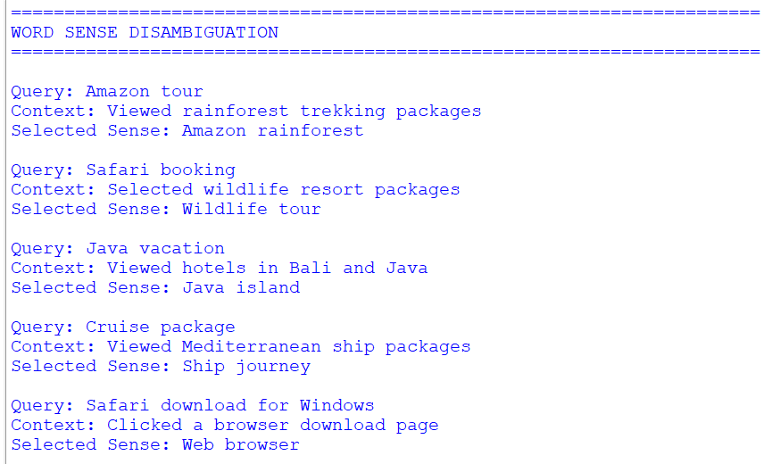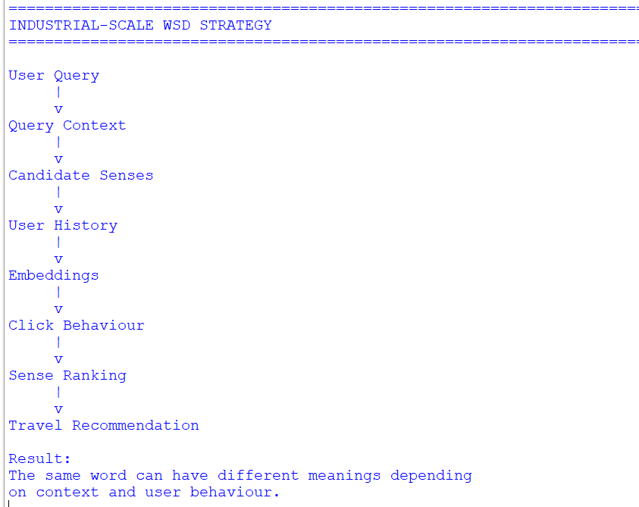

4. Syntax-Driven Semantic Analysis in Legal Documents

Task 1: Syntax and semantic roles
Syntax determines how words are grammatically connected, but grammatical position does not always equal semantic role.

Active voice
The supplier delivered the equipment to the buyer.
Correct roles:
Supplier = Agent
Equipment = Object/Theme
Buyer = Recipient

Second sentence
The buyer received the equipment from the supplier.
Correct roles:
Buyer = Recipient
Equipment = Object/Theme
Supplier = Source
Although buyer is the grammatical subject, it is not the Agent of the delivery event.

Passive voice
The contract was terminated by the company.
Correct roles:
Contract = Object/Theme
Company = Agent
The grammatical subject is contract, but the semantic Agent is company.

Task 2: Incorrect semantic-role assignments
There are two major incorrect interpretations.

Sentence 2
Given:
Buyer = Agent
Supplier = Recipient
This is incorrect.
Correct:
Buyer = Recipient
Supplier = Source/Agent

Sentence 4
Given:
Contract = Agent
Company = Object
This is incorrect.
Correct:
Contract = Object/Theme
Company = Agent

Sentence 1
This is essentially correct:
Supplier = Agent
Equipment = Object
Buyer = Recipient

Sentence 3
Also correct:
Company = Agent
Contract = Object

Task 3: Why confusing subject and Agent is dangerous
A grammatical subject is not necessarily the semantic Agent.
For example:
The contract was terminated by the company.
Grammatical subject:
contract
Semantic Agent:
company
If a legal NLP system assumes:
Subject = Agent
it could incorrectly conclude:
The contract terminated the company.
This can produce serious errors in:
- Contract analysis
- Liability identification
- Legal information extraction
- Compliance systems
- Case analysis
- Obligation extraction
Therefore, legal NLP needs semantic role labeling in addition to syntactic parsing.

Task 4: Recommended architecture
A strong legal NLP system can use:
Legal Document
↓
Sentence Segmentation
↓
Tokenization
↓
Dependency/Constituency Parsing
↓
Active/Passive Voice Detection
↓
Semantic Role Labeling
↓
Entity Recognition
↓
Coreference Resolution
↓
Long-Distance Dependency Handling
↓
Legal Relation Extraction
↓
Structured Legal Knowledge

Active voice handling
Company signed contract.

Company → Agent
Contract → Object

Passive voice handling
Contract was signed by company.

Contract → Object
Company → Agent

Prepositional phrase handling
Supplier delivered equipment to buyer.

Supplier → Agent
Equipment → Object
Buyer → Recipient

Long-distance dependency
The system should use dependency parsing and coreference resolution to connect participants even when they are separated by long clauses.

Conclusion
A syntax-driven semantic system should combine dependency parsing, voice detection, semantic role labeling, coreference resolution, and legal-domain rules. This prevents the common error of assuming that the grammatical subject is always the semantic Agent.
Code:
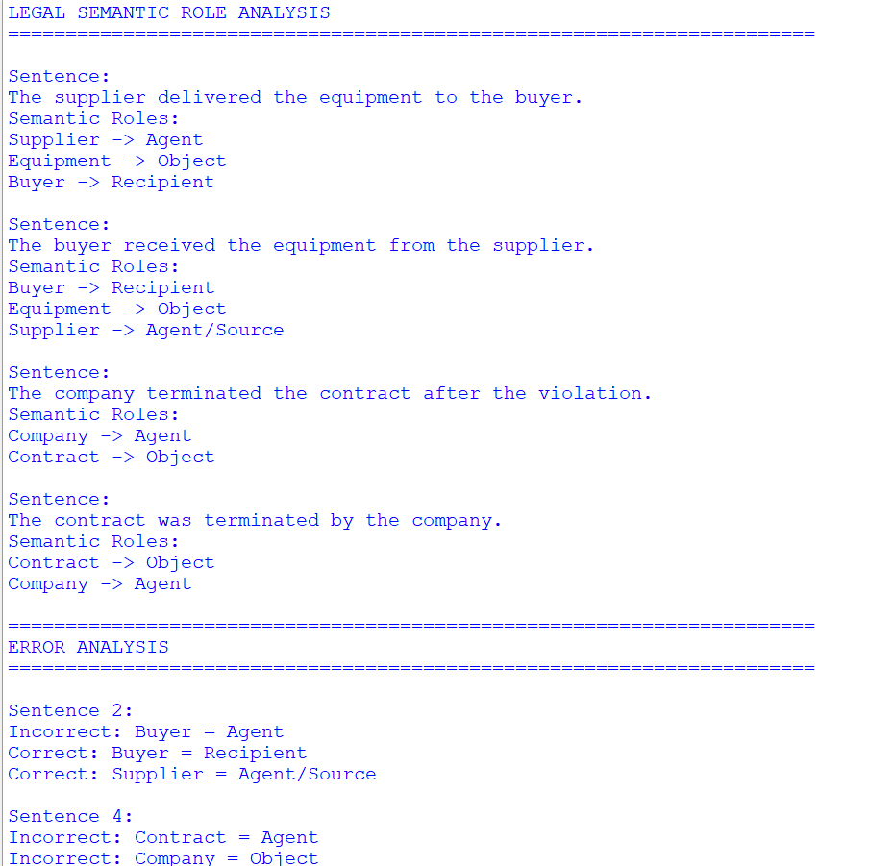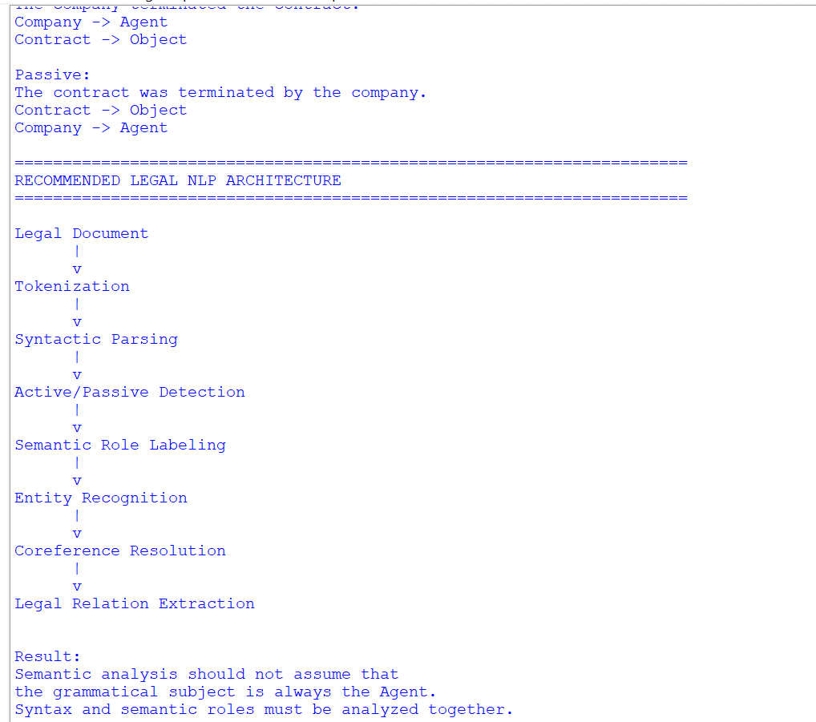

Rubrics for Calculation

Criteria | Weightage | Level 4 (Exemplary) | Level 3 (Proficient) | Level 2 (Developing) | Level 1 (Beginning)
Understanding of Data | 25% | Accurately interprets all data patterns, trends, and relationships | Interprets data correctly with minor gaps | Partial understanding; misses key trends | Misinterprets or fails to understand data
Analysis | 25% | Provides deep analysis with strong logical reasoning and justification | Provides reasonable analysis with some justification | Basic analysis with weak reasoning | No meaningful analysis provided
Application of Concepts | 20% | Effectively applies relevant concepts/tools to interpret data accurately | Applies concepts with minor errors | Limited application; requires guidance | Unable to apply concepts to data
Conclusion | 20% | Draws clear, meaningful conclusions with strong insights and implications | Provides valid conclusions with moderate insights | Conclusions are vague or weak | No clear or valid conclusions
Clarity | 10% | Presents interpretation clearly using proper structure, visuals, and terminology | Generally clear with minor issues | Lacks clarity or proper structure | Poor presentation and difficult to understand

Q. No. / Criteria Level | Understanding of Data | Analysis | Application of Concepts | Conclusion | Clarity | Sub. Total | Total %
1
2
3
4

Faculty In-charge | Course Coordinator | Program Director
Signature: _______________ | Signature: _______________ | Signature: _______________
Date: ___________________ | Date: ___________________ | Date: ___________________

